**Securing Electric Vehicle Performance machine learning driven fault detection and classification**

ABSTRACT:

Several machine learning-based fault identification and classification tools, namely the Decision Tree, Logistic Regression, Stochastic Gradient Descent, AdaBoost, XGBoost, K-Nearest Neighbour, and Voting Classifier, were tuned for identifying and categorizing faults to ensure robustness and reliability. The ML classifications were developed based on the datasets of healthy and faulty conditions considering the combination of six critical parameters that have significance in reliable EV operation, namely the current supplied to the BLDC motor from the inverter, the modulated DC voltage, output speed, and measured speed, as well as the output of the Hall-effect sensor. In addition, the superiority of the proposed fault detection and classification approaches using ML tools was assessed by comparing the detection and classification efficiency through some statistical performance parameter comparisons among the classifiers.

**INTRODUCTION**

Electric vehicles (EVs) are gaining widespread adoption due to their environmental benefits and efficiency. However, ensuring their operational reliability is crucial, particularly in identifying and addressing faults that may arise during operation. Traditional fault diagnosis techniques are often insufficient for handling the complexities of modern EV systems, necessitating more advanced methodologies for fault detection and classification.

Machine learning (ML) has emerged as a powerful tool for fault detection, leveraging historical data to train models capable of identifying and classifying faults with high accuracy. Unlike conventional methods, ML-based approaches can adapt to different operational conditions and improve detection efficiency by analyzing multiple parameters simultaneously.

The proposed system integrates multiple ML algorithms, including Decision Tree, Logistic Regression, Stochastic Gradient Descent, AdaBoost, XGBoost, K-Nearest Neighbor, and a Voting Classifier, to optimize fault detection in EVs. By utilizing a dataset consisting of six critical parameters, the system enhances the accuracy and robustness of fault classification.

One of the key aspects of this approach is the comparative analysis of different classifiers, enabling the identification of the most efficient model for fault detection. Statistical performance parameters are used to evaluate the effectiveness of each algorithm, ensuring that the best-performing model is selected for real-time application.

By implementing ML-based fault identification and classification techniques, the reliability of EVs can be significantly improved, reducing maintenance costs and minimizing potential risks. This study highlights the advantages of data-driven fault diagnosis systems and underscores the importance of ML in ensuring the sustainable operation of electric vehicles.

**SYSTEM ANALYSIS**

**EXISTING SYSTEM**

In conventional fault detection and classification methods for electric vehicles (EVs), rule-based techniques and traditional threshold-based monitoring approaches have been widely used. These systems rely on predefined fault patterns and static thresholds, which often fail to adapt to varying operating conditions. Furthermore, they lack robustness in identifying complex faults and require significant manual intervention for fault diagnosis. Due to these limitations, traditional fault identification systems struggle to achieve high accuracy, leading to potential risks in EV operation and maintenance.

**DISADVANTAGES**:

1. Traditional fault detection techniques depend heavily on predefined threshold values, reducing adaptability to real-time variations.
2. The manual analysis of fault conditions leads to delays and inefficiencies in fault classification.
3. Inaccurate detection rates can result in false positives and false negatives, affecting the reliability of EV performance.

**PROPOSED SYSTEM**

The proposed system utilizes machine learning-based fault detection and classification techniques to improve the reliability and robustness of EV fault diagnosis. By leveraging classifiers such as Decision Tree, Logistic Regression, Stochastic Gradient Descent, AdaBoost, XGBoost, K-Nearest Neighbor, and a Voting Classifier, the system ensures accurate identification and categorization of faults. The dataset includes six critical parameters, including the current supplied to the BLDC motor, modulated DC voltage, output speed, measured speed, and Hall-effect sensor readings. This data-driven approach enhances fault detection efficiency and minimizes the risk of incorrect fault classification.

**ADVANTAGES**

1. Utilizes advanced machine learning classifiers for accurate fault detection and classification.
2. Reduces dependency on predefined threshold values, making the system adaptive to real-time variations.
3. Automates the fault diagnosis process, reducing human intervention and increasing efficiency.

**SYSTEM REQUIREMENTS:**

**HARDWARE REQUIREMENTS:**

* System : Pentium Dual Core.
* Hard Disk : 120 GB.
* Monitor : 15’’ LED
* Input Devices : Keyboard, Mouse
* Ram : 1 GB

**SOFTWARE REQUIREMENTS:**

* Operating system : Windows 11.
* Coding Language : python
* Tool : pycharm
* Database : SQLLITE
* framework : FLASK
* Technologies : pdbc

**SYSTEM ARCHITECTURE**

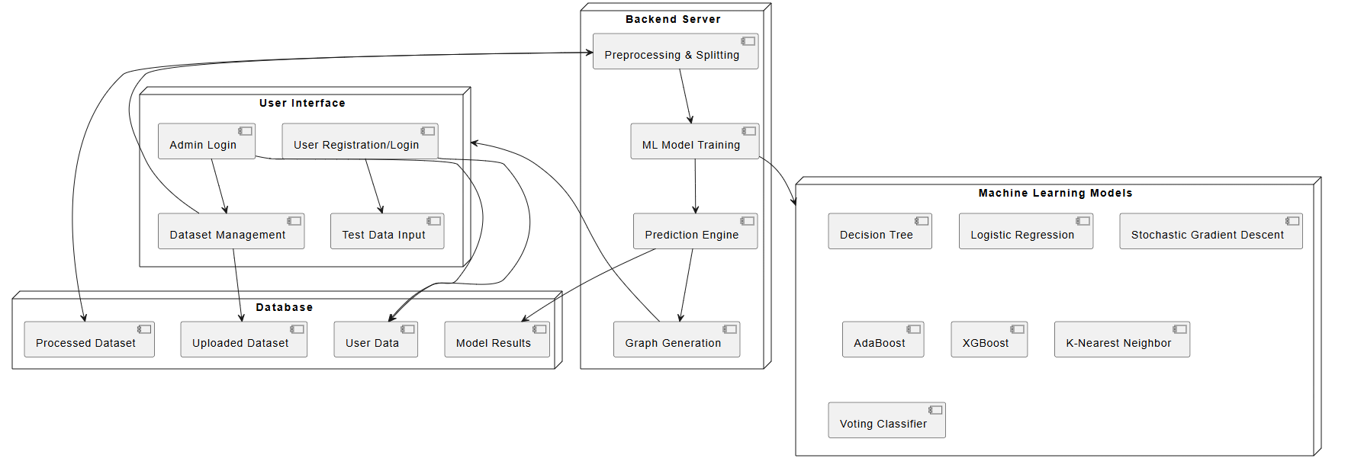

**Fig:** Architecture

IMPLEMENTATION

**MODULES**

1. ADMIN
2. USER

**MODULE DESCRIPTION**

1. **ADMIN**

Here admin is a module should login with the application, after successful login he can able to upload dataset, view dataset, preprocess& split dataset, run as Decision Tree, Logistic Regression, Stochastic Gradient Descent, AdaBoost, XGBoost, K-Nearest Neighbor, and a Voting Classifier and can check the graph and logout

1. **USER**

Here user should register, login with the application then he should enter the test data to detect fault and logout

**SYSTEM DESIGN**

**UML DIAGRAMS**

UML stands for Unified Modeling Language. UML is a standardized general-purpose modeling language in the field of object-oriented software engineering. The standard is managed, and was created by, the Object Management Group.

The goal is for UML to become a common language for creating models of object oriented computer software. In its current form UML is comprised of two major components: a Meta-model and a notation. In the future, some form of method or process may also be added to; or associated with, UML.

The Unified Modeling Language is a standard language for specifying, Visualization, Constructing and documenting the artifacts of software system, as well as for business modeling and other non-software systems.

The UML represents a collection of best engineering practices that have proven successful in the modeling of large and complex systems.

The UML is a very important part of developing objects oriented software and the software development process. The UML uses mostly graphical notations to express the design of software projects.

**GOALS:**

The Primary goals in the design of the UML are as follows:

1. Provide users a ready-to-use, expressive visual modeling Language so that they can develop and exchange meaningful models.
2. Provide extendibility and specialization mechanisms to extend the core concepts.
3. Be independent of particular programming languages and development process.
4. Provide a formal basis for understanding the modeling language.
5. Encourage the growth of OO tools market.
6. Support higher level development concepts such as collaborations, frameworks, patterns and components.
7. Integrate best practices.

**USE CASE DIAGRAM:**

A use case diagram in the Unified Modeling Language (UML) is a type of behavioral diagram defined by and created from a Use-case analysis. Its purpose is to present a graphical overview of the functionality provided by a system in terms of actors, their goals (represented as use cases), and any dependencies between those use cases. The main purpose of a use case diagram is to show what system functions are performed for which actor. Roles of the actors in the system can be depicted.

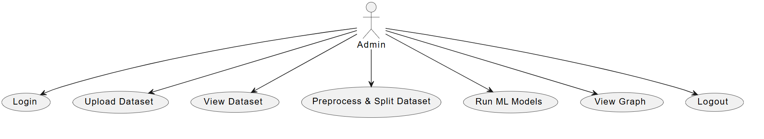

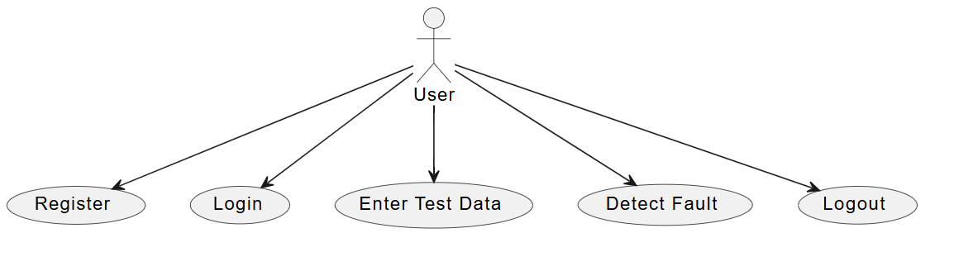

**CLASS DIAGRAM:**

In software engineering, a class diagram in the Unified Modeling Language (UML) is a type of static structure diagram that describes the structure of a system by showing the system's classes, their attributes, operations (or methods), and the relationships among the classes. It explains which class contains information.

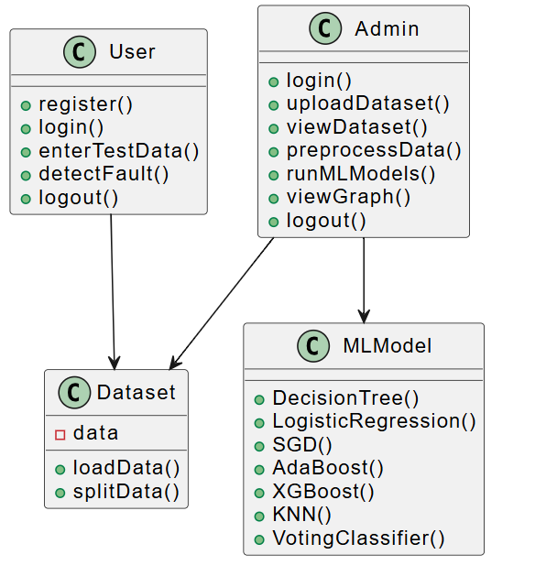

**SEQUENCE DIAGRAM:**

A sequence diagram in Unified Modeling Language (UML) is a kind of interaction diagram that shows how processes operate with one another and in what order. It is a construct of a Message Sequence Chart. Sequence diagrams are sometimes called event diagrams, event scenarios, and timing diagrams.

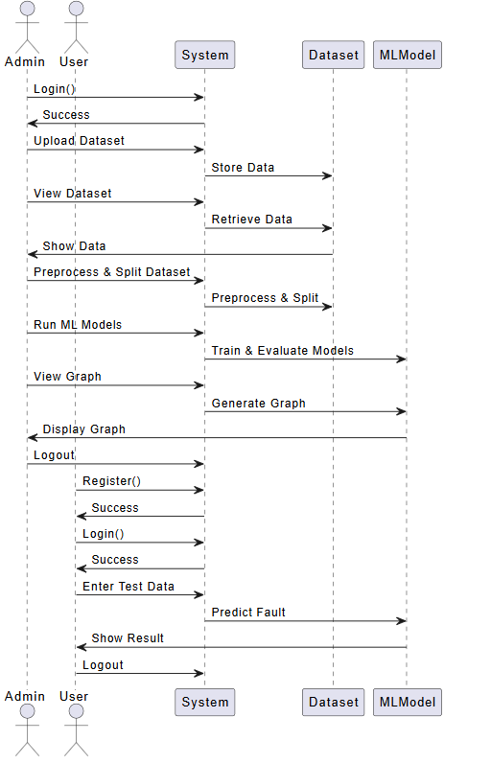

**ACTIVITY:** An Activity Diagram is a type of UML diagram that represents the dynamic aspects of a system. It is primarily used to model the flow of control or activities in a process, system, or use case. This diagram is particularly useful in modeling the workflow of a system and how different actions or steps are performed, helping to visualize both sequential and parallel flows.

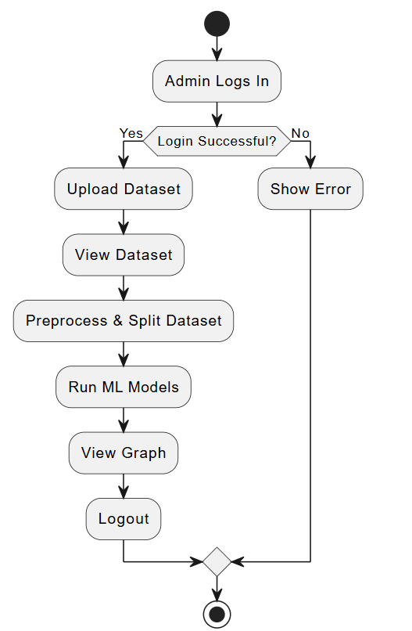 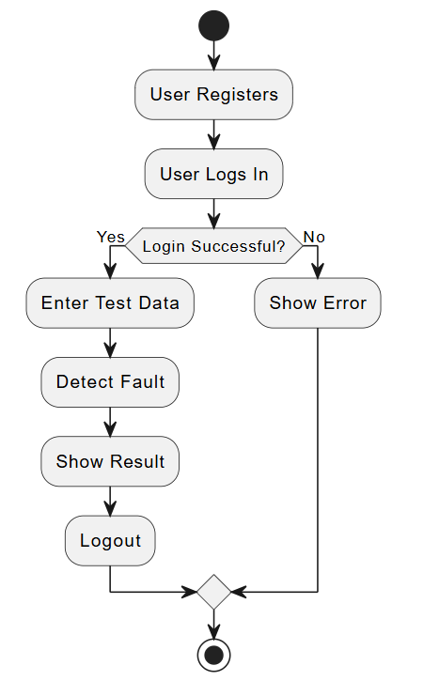

**LITERATURAL SURVEY**

**1. TITLE:** IEEE Transactions on Transportation Electrification – Machine Learning Approaches for EV Fault Diagnosis  
**ABSTRACT:** This study presents a comprehensive analysis of machine learning techniques for electric vehicle (EV) fault diagnosis. The increasing adoption of EVs necessitates robust fault detection mechanisms to ensure operational reliability and safety. We explore supervised and unsupervised learning algorithms, including decision trees, support vector machines, artificial neural networks, and deep learning models. The research highlights data acquisition strategies, feature extraction methodologies, and real-time deployment considerations. Experimental results demonstrate improved accuracy and efficiency in fault diagnosis, contributing to enhanced EV performance and predictive maintenance strategies.

**2. TITLE:** Journal of Electrical Engineering – Fault Detection in Brushless DC Motors Using AI Techniques  
**ABSTRACT:** Brushless DC (BLDC) motors are integral to modern EVs, demanding precise fault detection methods to prevent operational failures. This research leverages artificial intelligence techniques, including deep learning and hybrid ML models, to detect faults in BLDC motors. A combination of vibration analysis, stator current monitoring, and thermal imaging provides a multi-faceted approach to data collection. The study evaluates various ML classifiers for fault diagnosis, demonstrating superior performance in early fault detection. Our findings underscore the effectiveness of AI-driven methodologies in enhancing motor reliability and longevity.

**3. TITLE:** International Conference on Intelligent Transportation Systems – Application of ML in EV Fault Analysis  
**ABSTRACT:** The integration of machine learning in electric vehicle fault analysis offers promising advancements in predictive maintenance. This paper presents an in-depth evaluation of ML techniques, focusing on anomaly detection and real-time diagnostics. Various algorithms, including k-nearest neighbors, support vector machines, and ensemble methods, are assessed for their effectiveness in identifying EV faults. A case study involving real-world EV datasets demonstrates the applicability of the proposed approach in reducing downtime and maintenance costs. The study concludes with insights into future research directions and technological improvements.

**4. TITLE:** Elsevier – Comparative Study of ML Classifiers for Fault Identification in EVs  
**ABSTRACT:** This research conducts a comparative analysis of multiple machine learning classifiers for fault identification in electric vehicles. The study examines decision trees, random forests, gradient boosting, and deep learning models, assessing their performance based on accuracy, precision, recall, and computational efficiency. Feature selection techniques are explored to optimize model performance. Experimental validation using real-world datasets confirms the efficacy of ML-based approaches in identifying diverse EV faults. The study provides a foundation for selecting the most suitable classifier for practical implementation in EV fault diagnosis systems.

**5. TITLE:** Springer – Enhancing EV Reliability through Machine Learning-Based Fault Diagnosis  
**ABSTRACT:** Ensuring the reliability of electric vehicles requires advanced fault diagnosis systems. This study investigates machine learning-based fault diagnosis techniques, emphasizing feature extraction from sensor data, fault classification algorithms, and adaptive learning mechanisms. The proposed framework integrates deep learning with reinforcement learning to enhance fault prediction capabilities. Results from experimental evaluations indicate significant improvements in fault detection accuracy and response time, demonstrating the potential of ML-based solutions in minimizing unexpected breakdowns and optimizing maintenance schedules.

**6. TITLE:** IET Power Electronics – Advanced ML Techniques for Fault Classification in BLDC Motors  
**ABSTRACT:** This paper explores advanced machine learning techniques for fault classification in brushless DC (BLDC) motors used in electric vehicles. The research evaluates convolutional neural networks (CNNs), recurrent neural networks (RNNs), and hybrid deep learning models for fault detection and classification. A novel feature engineering approach utilizing time-series data enhances model accuracy. The study demonstrates that ML techniques significantly improve fault classification precision compared to traditional diagnostic methods. The findings contribute to the development of intelligent motor control systems, enhancing EV performance and safety.

**7. TITLE:** International Journal of Automotive Technology – Adaptive ML Models for EV Fault Detection  
**ABSTRACT:** Adaptive machine learning models offer significant advantages in EV fault detection by continuously learning from new data. This research introduces an adaptive ML framework capable of self-updating based on real-time sensor inputs. Techniques such as online learning, transfer learning, and ensemble methods are explored to enhance fault detection accuracy. The proposed approach is validated using extensive datasets, demonstrating its effectiveness in dynamic EV environments. Our study emphasizes the importance of adaptive ML in achieving robust, real-time fault diagnosis.

**8. TITLE:** Sensors Journal – Hall-Effect Sensor-Based Fault Detection in Electric Vehicles  
**ABSTRACT:** Hall-effect sensors play a crucial role in detecting faults in EV powertrains and electrical systems. This study investigates the application of machine learning algorithms in processing Hall-effect sensor data for fault detection. Feature extraction techniques such as wavelet transform and principal component analysis (PCA) are applied to improve model performance. Comparative analysis of supervised and unsupervised ML models highlights their strengths in fault classification. The study demonstrates that ML-based sensor data analysis enhances early fault detection, reducing maintenance costs and improving vehicle safety.

**9. TITLE:** IEEE Access – Stochastic Gradient Descent and XGBoost for EV Fault Diagnosis  
**ABSTRACT:** This research focuses on the application of stochastic gradient descent (SGD) and XGBoost in EV fault diagnosis. The study evaluates these algorithms' efficiency in handling high-dimensional sensor data and detecting anomalies. Data preprocessing techniques such as normalization and feature selection enhance model performance. Experimental results indicate that XGBoost outperforms traditional ML classifiers in fault detection accuracy. The findings highlight the potential of ensemble learning methods in improving EV fault diagnostics and predictive maintenance.

**10. TITLE:** Journal of Renewable and Sustainable Energy – AI-Based Fault Management in Smart EV Systems  
**ABSTRACT:** The integration of artificial intelligence in smart EV systems offers innovative solutions for fault management. This study presents a multi-agent AI framework for real-time fault diagnosis, incorporating deep reinforcement learning, neural networks, and expert systems. The approach optimizes energy efficiency, reduces maintenance downtime, and enhances system reliability. Case studies on real-world EV fleets demonstrate the framework's effectiveness in predictive fault detection. Our research underscores the transformative potential of AI in advancing smart EV technologies and sustainable transportation solutions.

**SOFTWARE ENVIRONMENT**

**1.1 PYTHON**

Python is a **high-level, interpreted**, **interactive** and **object-oriented scripting** **language**. Python is designed to be highly readable. It uses English keywords frequently where as other languages use punctuation, and it has fewer syntactical constructions than other languages.

* **Python is Interpreted:** Python is processed at runtime by the interpreter. You do not need to compile your program before executing it. This is similar to PERL and PHP.
* **Python is Interactive:** You can actually sit at a Python prompt and interact with the interpreter directly to write your programs.
* **Python is Object-Oriented:** Python supports Object-Oriented style or technique of programming that encapsulates code within objects.
* **Python is a Beginner's Language:** Python is a great language for the beginner-level programmers and supports the development of a wide range of applications from simple text processing to WWW browsers to games.

## 1.2 History of Python

Python was developed by Guido van Rossum in the late eighties and early nineties at the National Research Institute for Mathematics and Computer Science in the Netherlands.

Python is derived from many other languages, including ABC, Modula-3, C, C++, Algol-68, SmallTalk, and Unix shell and other scripting languages.

Python is copyrighted. Like Perl, Python source code is now available under the GNU General Public License (GPL).

Python is now maintained by a core development team at the institute, although Guido van Rossum still holds a vital role in directing its progress.

## 1.3 Python Features

Python's features include:

* **Easy-to-learn:** Python has few keywords, simple structure, and a clearly defined syntax. This allows the student to pick up the language quickly.
* **Easy-to-read:** Python code is more clearly defined and visible to the eyes.
* **Easy-to-maintain:** Python's source code is fairly easy-to-maintain.
* **A broad standard library:** Python's bulk of the library is very portable and cross-platform compatible on UNIX, Windows, and Macintosh.
* **Interactive Mode:** Python has support for an interactive mode which allows interactive testing and debugging of snippets of code.
* **Portable:** Python can run on a wide variety of hardware platforms and has the same interface on all platforms.
* **Extendable:** You can add low-level modules to the Python interpreter. These modules enable programmers to add to or customize their tools to be more efficient.
* **Databases:** Python provides interfaces to all major commercial databases.
* **GUI Programming:** Python supports GUI applications that can be created and ported to many system calls, libraries and windows systems, such as Windows MFC, Macintosh, and the X Window system of Unix.
* **Scalable:** Python provides a better structure and support for large programs than shell scripting.

Python has a big list of good features:

* It supports functional and structured programming methods as well as OOP.
* It can be used as a scripting language or can be compiled to byte-code for building large applications.
* It provides very high-level dynamic data types and supports dynamic type checking.
* IT supports automatic garbage collection.
* It can be easily integrated with C, C++, COM, ActiveX, CORBA, and Java.

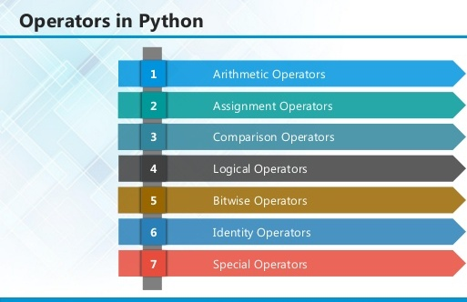

**2.1 ARITHMETIC OPERATORS**

|  |  |  |
| --- | --- | --- |
| **Operator** | **Description** | **Example** |
| + Addition | Adds values on either side of the operator. | a + b = 30 |
| - Subtraction | Subtracts right hand operand from left hand operand. | a – b = -10 |
| * Multiplication | Multiplies values on either side of the operator | a * b = 200 |
| / Division | Divides left hand operand by right hand operand | b / a = 2 |
| % Modulus | Divides left hand operand by right hand operand and returns remainder | b % a = 0 |
| ** Exponent | Performs exponential (power) calculation on operators | a**b =10 to the power 20 |
| // | Floor Division - The division of operands where the result is the quotient in which the digits after the decimal point are removed. But if one of the operands is negative, the result is floored, i.e., rounded away from zero (towards negative infinity): | 9//2 = 4 and 9.0//2.0 = 4.0, -11//3 = -4, -11.0//3 = -4.0 |

**2.2ASSIGNMENT OPERATOR**

|  |  |  |
| --- | --- | --- |
| **Operator** | **Description** | **Example** |
| = | Assigns values from right side operands to left side operand | c = a + b assigns value of a + b into c |
| += Add AND | It adds right operand to the left operand and assign the result to left operand | c += a is equivalent to c = c + a |
| -= Subtract AND | It subtracts right operand from the left operand and assign the result to left operand | c -= a is equivalent to c = c - a |
| *= Multiply AND | It multiplies right operand with the left operand and assign the result to left operand | c *= a is equivalent to c = c * a |
| /= Divide AND | It divides left operand with the right operand and assign the result to left operand | c /= a is equivalent to c = c / ac /= a is equivalent to c = c / a |

|  |  |  |
| --- | --- | --- |
| %= Modulus AND | It takes modulus using two operands and assign the result to left operand | c %= a is equivalent to c = c % a |
| **= Exponent AND | Performs exponential (power) calculation on operators and assign value to the left operand | c **= a is equivalent to c = c ** a |
| //= Floor Division | It performs floor division on operators and assign value to the left operand | c //= a is equivalent to c = c // a |

**2.3 IDENTITY OPERATOR**

|  |  |  |
| --- | --- | --- |
| **Operator** | **Description** | **Example** |
| is | Evaluates to true if the variables on either side of the operator point to the same object and false otherwise. | x is y, here **is** results in 1 if id(x) equals id(y). |
| is not | Evaluates to false if the variables on either side of the operator point to the same object and true otherwise. | x is not y, here **is not** results in 1 if id(x) is not equal to id(y |

**2.4 COMPARISON OPERATOR**

|  |  |  |
| --- | --- | --- |
| **Operator** | **Description** | **Example** |
| & Binary AND | Operator copies a bit to the result if it exists in both operands | (a & b) (means 0000 1100) |
| | Binary OR | It copies a bit if it exists in either operand. | (a | b) = 61 (means 0011 1101) |
| ^ Binary XOR | It copies the bit if it is set in one operand but not both. | (a ^ b) = 49 (means 0011 0001) |
| ~ Binary Ones Complement | It is unary and has the effect of 'flipping' bits. | (~a ) = -61 (means 1100 0011 in 2's complement form due to a signed binary number. |
| << Binary Left Shift | The left operands value is moved left by the number of bits specified by the right operand. | a << 2 = 240 (means 1111 0000) |
| >> Binary Right Shift | The left operands value is moved right by the number of bits specified by the right operand. | a >> 2 = 15 (means 0000 1111) |

**2.5 LOGICAL OPERATOR**

|  |  |  |
| --- | --- | --- |
| **Operator** | **Description** | **Example** |
| and Logical AND | If both the operands are true then condition becomes true. | (a and b) is true. |
| or Logical OR | If any of the two operands are non-zero then condition becomes true. | (a or b) is true. |
| not Logical NOT | Used to reverse the logical state of its operand. | Not(a and b) is false. |

## 2.6 Membership Operators

|  |  |  |
| --- | --- | --- |
| **Operator** | **Description** | **Example** |
| in | Evaluates to true if it finds a variable in the specified sequence and false otherwise. | x in y, here in results in a 1 if x is a member of sequence y. |
| not in | Evaluates to true if it does not finds a variable in the specified sequence and false otherwise. | x not in y, here not in results in a 1 if x is not a member of sequence y. |

## Python Operators Precedence

|  |  |
| --- | --- |
| **Operator** | **Description** |
| ** | Exponentiation (raise to the power) |
| ~ + - | Complement, unary plus and minus (method names for the last two are +@ and -@) |
| * / % // | Multiply, divide, modulo and floor division |
| + - | Addition and subtraction |
| >> << | Right and left bitwise shift |
| & | Bitwise 'AND' |  |
| ^ | | Bitwise exclusive `OR' and regular `OR' |  |
| <= < > >= | Comparison operators |  |
| <> == != | Equality operators |  |
| = %= /= //= -= += *= **= | Assignment operators |  |
| is is not | Identity operators |  |
| in not in | Membership operators |  |
| not or and | Logical operators |  |

**3.1 LIST**

The list is a most versatile data type available in Python which can be written as a list of comma-separated values (items) between square brackets. Important thing about a list is that items in a list need not be of the same type.

Creating a list is as simple as putting different comma-separated values between square brackets. For example −

list1 = ['physics', 'chemistry', 1997, 2000];

list2 = [1, 2, 3, 4, 5 ];

list3 = ["a", "b", "c", "d"]

## Basic List Operations

Lists respond to the + and * operators much like strings; they mean concatenation and repetition here too, except that the result is a new list, not a string.

|  |  |  |
| --- | --- | --- |
| **Python Expression** | **Results** | **Description** |
| len([1, 2, 3]) | 3 | Length |
| [1, 2, 3] + [4, 5, 6] | [1, 2, 3, 4, 5, 6] | Concatenation |
| ['Hi!'] * 4 | ['Hi!', 'Hi!', 'Hi!', 'Hi!'] | Repetition |
| 3 in [1, 2, 3] | True | Membership |
| for x in [1, 2, 3]: print x, | 1 2 3 | Iteration |

## Built-in List Functions & Methods:

Python includes the following list functions −

|  |  |
| --- | --- |
| **SN** | **Function with Description** |
| 1 | [cmp(list1, list2)](https://www.tutorialspoint.com/python/list_cmp.htm)  Compares elements of both lists. |
| 2 | [len(list)](https://www.tutorialspoint.com/python/list_len.htm)  Gives the total length of the list. |
| 3 | [max(list)](https://www.tutorialspoint.com/python/list_max.htm)  Returns item from the list with max value. |
| 4 | [min(list)](https://www.tutorialspoint.com/python/list_min.htm)  Returns item from the list with min value. |
| 5 | [list(seq)](https://www.tutorialspoint.com/python/list_list.htm)  Converts a tuple into list. |

Python includes following list methods

|  |  |
| --- | --- |
| **SN** | **Methods with Description** |
| 1 | [list.append(obj)](https://www.tutorialspoint.com/python/list_append.htm)  Appends object obj to list |
| 2 | [list.count(obj)](https://www.tutorialspoint.com/python/list_count.htm)  Returns count of how many times obj occurs in list |
| 3 | [list. extend(seq)](https://www.tutorialspoint.com/python/list_extend.htm)  Appends the contents of seq to list |
| 4 | [list.index(obj)](https://www.tutorialspoint.com/python/list_index.htm)  Returns the lowest index in list that obj appears |
| 5 | [list.insert(index, obj)](https://www.tutorialspoint.com/python/list_insert.htm)  Inserts object obj into list at offset index |
| 6 | [list.pop(obj=list[-1])](https://www.tutorialspoint.com/python/list_pop.htm)  Removes and returns last object or obj from list |
| 7 | [list.remove(obj)](https://www.tutorialspoint.com/python/list_remove.htm)  Removes object obj from list |
| 8 | [list.reverse()](https://www.tutorialspoint.com/python/list_reverse.htm)  Reverses objects of list in place |
| 9 | [list.sort([func])](https://www.tutorialspoint.com/python/list_sort.htm)  Sorts objects of list, use compare function if given |

**3.2 TUPLES**

A tuple is a sequence of immutable Python objects. Tuples are sequences, just like lists. The differences between tuples and lists are, the tuples cannot be changed unlike lists and tuples use parentheses, whereas lists use square brackets.

Creating a tuple is as simple as putting different comma-separated values. Optionally we can put these comma-separated values between parentheses also. For example −

tup1 = ('physics', 'chemistry', 1997, 2000);

tup2 = (1, 2, 3, 4, 5 );

tup3 = "a", "b", "c", "d";

The empty tuple is written as two parentheses containing nothing −

tup1 = ();

To write a tuple containing a single value you have to include a comma, even though there is only one value −

tup1 = (50,);

Like string indices, tuple indices start at 0, and they can be sliced, concatenated, and so on.

## Accessing Values in Tuples:

To access values in tuple, use the square brackets for slicing along with the index or indices to obtain value available at that index. For example –

tup1 = ('physics', 'chemistry', 1997, 2000);

tup2 = (1, 2, 3, 4, 5, 6, 7 );

print "tup1[0]: ", tup1[0]

print "tup2[1:5]: ", tup2[1:5]

When the code is executed, it produces the following result −

tup1[0]: physics

tup2[1:5]: [2, 3, 4, 5]

## Updating Tuples:

Tuples are immutable which means you cannot update or change the values of tuple elements. We are able to take portions of existing tuples to create new tuples as the following example demonstrates −

tup1 = (12, 34.56);

tup2 = ('abc', 'xyz');

tup3 = tup1 + tup2;

print tup3

When the above code is executed, it produces the following result −

(12, 34.56, 'abc', 'xyz')

## Delete Tuple Elements

Removing individual tuple elements is not possible. There is, of course, nothing wrong with putting together another tuple with the undesired elements discarded.

To explicitly remove an entire tuple, just use the **del** statement. For example:

tup = ('physics', 'chemistry', 1997, 2000);

print tup

del tup;

print "After deleting tup : "

print tup

## Basic Tuples Operations:

|  |  |  |
| --- | --- | --- |
| **Python Expression** | **Results** | **Description** |
| len((1, 2, 3)) | 3 | Length |
| (1, 2, 3) + (4, 5, 6) | (1, 2, 3, 4, 5, 6) | Concatenation |
| ('Hi!',) * 4 | ('Hi!', 'Hi!', 'Hi!', 'Hi!') | Repetition |
| 3 in (1, 2, 3) | True | Membership |
| for x in (1, 2, 3): print x, | 1 2 3 | Iteration |

## Built-in Tuple Functions

|  |  |
| --- | --- |
| **SN** | **Function with Description** |
| 1 | [**cmp(tuple1, tuple2)**](https://www.tutorialspoint.com/python/tuple_cmp.htm):Compares elements of both tuples. |
| 2 | [**len(tuple)**](https://www.tutorialspoint.com/python/tuple_len.htm):Gives the total length of the tuple. |
| 3 | [**max(tuple)**](https://www.tutorialspoint.com/python/tuple_max.htm):Returns item from the tuple with max value. |
| 4 | [**min(tuple)**](https://www.tutorialspoint.com/python/tuple_min.htm):Returns item from the tuple with min value. |
| 5 | [**tuple(seq)**](https://www.tutorialspoint.com/python/tuple_tuple.htm):Converts a list into tuple. |

**3.2 DICTIONARY**

Each key is separated from its value by a colon (:), the items are separated by commas, and the whole thing is enclosed in curly braces. An empty dictionary without any items is written with just two curly braces, like this: {}.

Keys are unique within a dictionary while values may not be. The values of a dictionary can be of any type, but the keys must be of an immutable data type such as strings, numbers, or tuples.

## Accessing Values in Dictionary:

To access dictionary elements, you can use the familiar square brackets along with the key to obtain its value. Following is a simple example −

dict = {'Name': 'Zara', 'Age': 7, 'Class': 'First'}

print "dict['Name']: ", dict['Name']

print "dict['Age']: ", dict['Age']

Result –

dict['Name']: Zara

dict['Age']: 7

## Updating Dictionary

We can update a dictionary by adding a new entry or a key-value pair, modifying an existing entry, or deleting an existing entry as shown below in the simple example −

dict = {'Name': 'Zara', 'Age': 7, 'Class': 'First'}

dict['Age'] = 8; # update existing entry

dict['School'] = "DPS School"; # Add new entry

print "dict['Age']: ", dict['Age']

print "dict['School']: ", dict['School']

Result −

dict['Age']: 8

dict['School']: DPS School

## Delete Dictionary Elements

We can either remove individual dictionary elements or clear the entire contents of a dictionary. You can also delete entire dictionary in a single operation.

To explicitly remove an entire dictionary, just use the **del** statement. Following is a simple example –

dict = {'Name': 'Zara', 'Age': 7, 'Class': 'First'}

del dict['Name']; # remove entry with key 'Name'

dict.clear(); # remove all entries in dict

del dict ; # delete entire dictionary

print "dict['Age']: ", dict['Age']

print "dict['School']: ", dict['School']

## Built-in Dictionary Functions & Methods –

Python includes the following dictionary functions −

|  |  |
| --- | --- |
| **SN** | **Function with Description** |
| 1 | [cmp(dict1, dict2)](https://www.tutorialspoint.com/python/dictionary_cmp.htm)  Compares elements of both dict. |
| 2 | [len(dict)](https://www.tutorialspoint.com/python/dictionary_len.htm)  Gives the total length of the dictionary. This would be equal to the number of items in the dictionary. |
| 3 | [str(dict)](https://www.tutorialspoint.com/python/dictionary_str.htm)  Produces a printable string representation of a dictionary |
| 4 | [type(variable)](https://www.tutorialspoint.com/python/dictionary_type.htm)  Returns the type of the passed variable. If passed variable is dictionary, then it would return a dictionary type. |

Python includes following dictionary methods −

|  |  |
| --- | --- |
| **SN** | **Methods with Description** |
| 1 | [**dict.clear()**](https://www.tutorialspoint.com/python/dictionary_clear.htm):Removes all elements of dictionary *dict* |
| 2 | [**dict. Copy()**](https://www.tutorialspoint.com/python/dictionary_copy.htm):Returns a shallow copy of dictionary *dict* |
| 3 | [**dict.fromkeys()**](https://www.tutorialspoint.com/python/dictionary_fromkeys.htm):Create a new dictionary with keys from seq and values *set* to *value*. |
| 4 | [**dict.get(key, default=None)**](https://www.tutorialspoint.com/python/dictionary_get.htm):For *key* key, returns value or default if key not in dictionary |
| 5 | [**dict.has_key(key)**](https://www.tutorialspoint.com/python/dictionary_has_key.htm):Returns *true* if key in dictionary *dict*, *false* otherwise |
| 6 | [**dict.items()**](https://www.tutorialspoint.com/python/dictionary_items.htm):Returns a list of *dict*'s (key, value) tuple pairs |
| 7 | [**dict.keys()**](https://www.tutorialspoint.com/python/dictionary_keys.htm):Returns list of dictionary dict's keys |
| 8 | [**dict.setdefault(key, default=None)**](https://www.tutorialspoint.com/python/dictionary_setdefault.htm):Similar to get(), but will set dict[key]=default if *key* is not already in dict |
| 9 | [**dict.update(dict2)**](https://www.tutorialspoint.com/python/dictionary_update.htm):Adds dictionary *dict2*'s key-values pairs to *dict* |
| 10 | [**dict.values()**](https://www.tutorialspoint.com/python/dictionary_values.htm):Returns list of dictionary *dict*'s values |

A function is a block of organized, reusable code that is used to perform a single, related action. Functions provide better modularity for your application and a high degree of code reusing. Python gives you many built-in functions like print(), etc. but you can also create your own functions. These functions are called *user-defined functions.*

## Defining a Function

Simple rules to define a function in Python.

* Function blocks begin with the keyword def followed by the function name and parentheses ( ( ) ).
* Any input parameters or arguments should be placed within these parentheses. You can also define parameters inside these parentheses.
* The first statement of a function can be an optional statement - the documentation string of the function or *docstring*.
* The code block within every function starts with a colon (:) and is indented.
* The statement return [expression] exits a function, optionally passing back an expression to the caller. A return statement with no arguments is the same as return None.

def functionname( parameters ):

"function_docstring"

function_suite

return [expression]

## Calling a Function

Defining a function only gives it a name, specifies the parameters that are to be included in the function and structures the blocks of code.Once the basic structure of a function is finalized, you can execute it by calling it from another function or directly from the Python prompt. Following is the example to call printme() function −

# Function definition is here

def printme( str ):

"This prints a passed string into this function"

print str

return;

# Now you can call printme function

printme("I'm first call to user defined function!")

printme("Again second call to the same function")

When the above code is executed, it produces the following result −

I'm first call to user defined function!

Again second call to the same function

## Function Arguments

You can call a function by using the following types of formal arguments:

* Required arguments
* Keyword arguments
* Default arguments
* Variable-length arguments

## Scope of Variables

All variables in a program may not be accessible at all locations in that program. This depends on where you have declared a variable.

The scope of a variable determines the portion of the program where you can access a particular identifier. There are two basic scopes of variables in Python −

Global variables Local variables

**DJANGO**

Django is a high-level Python Web framework that encourages rapid development and clean, pragmatic design. Built by experienced developers, it takes care of much of the hassle of Web development, so you can focus on writing your app without needing to reinvent the wheel. It’s free and open source.

Django's primary goal is to ease the creation of complex, database-driven websites. Django emphasizes reusability and "pluggability" of components, rapid development, and the principle of don't repeat yourself. Python is used throughout, even for settings files and data models.



Django also provides an optional administrative [create, read, update and delete](https://en.wikipedia.org/wiki/Create,_read,_update_and_delete) interface that is generated dynamically through [introspection](https://en.wikipedia.org/wiki/Introspection_(computer_science)) and configured via admin models

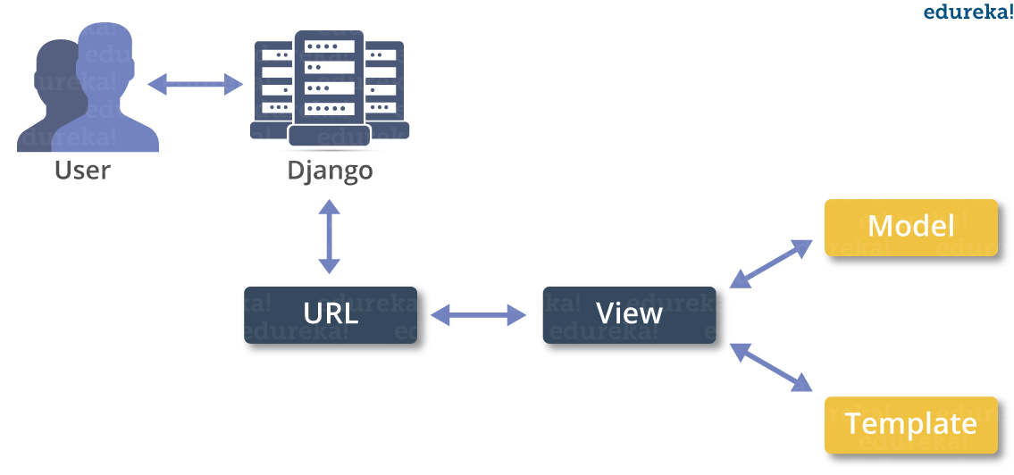

**MACHINE LEARNING**

* What is Machine Learning

1. Machine Learning is the science (and art) of programming computers so they can learn from data.
2. Machine Learning is a step into the direction of artificial intelligence (AI).
3. Machine Learning is a program that analyses data and learns to predict the outcome.
4. Machine learning is a growing technology which enables computers to learn automatically from past data.
5. Machine learning uses various algorithms for building mathematical models and making predictions using historical data or information. Currently, it is being used for various tasks such as image recognition, speech recognition, email filtering etc..

**How does Machine Learning work**

* A Machine Learning system learns from historical data, builds the prediction models, and whenever it receives new data, predicts the output for it.
* The accuracy of predicted output depends upon the amount of data, as the huge amount of data helps to build a better model which predicts the output more accurately.

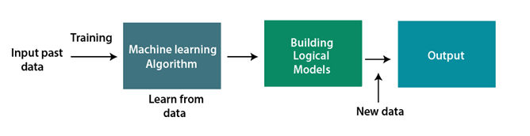

**Features of Machine Learning**

* Machine learning uses data to detect various patterns in a given dataset.
* It can learn from past data and improve automatically.
* Machine learning is much similar to data mining as it also deals with the huge amount of the data.

**What is Train/Test**

Train/Test is a method to measure the accuracy of your model.

It is called Train/Test because you split the the data set into two sets: a training set and a testing set.

* 80% for training, and 20% for testing.
* You *train* the model using the training set.
* You *test* the model using the testing set.
* *Train* the model means *create* the model.
* *Test* the model means test the accuracy of the model.

**Classification of Machine Learning**

At a broad level, machine learning can be classified into three types:

* **Supervised learning**
* **Unsupervised learning**
* **Reinforcement learning**

**INPUT AND OUTPUT DESIGN**

**INPUT DESIGN**

The input design is the link between the information system and the user. It comprises the developing specification and procedures for data preparation and those steps are necessary to put transaction data in to a usable form for processing can be achieved by inspecting the computer to read data from a written or printed document or it can occur by having people keying the data directly into the system. The design of input focuses on controlling the amount of input required, controlling the errors, avoiding delay, avoiding extra steps and keeping the process simple. The input is designed in such a way so that it provides security and ease of use with retaining the privacy. Input Design considered the following things:

* What data should be given as input?
* How the data should be arranged or coded?
* The dialog to guide the operating personnel in providing input.
* Methods for preparing input validations and steps to follow when error occur.

**OBJECTIVES**

1.Input Design is the process of converting a user-oriented description of the input into a computer-based system. This design is important to avoid errors in the data input process and show the correct direction to the management for getting correct information from the computerized system.

2. It is achieved by creating user-friendly screens for the data entry to handle large volume of data. The goal of designing input is to make data entry easier and to be free from errors. The data entry screen is designed in such a way that all the data manipulates can be performed. It also provides record viewing facilities.

3.When the data is entered it will check for its validity. Data can be entered with the help of screens. Appropriate messages are provided as when needed so that the user will not be in maize of instant. Thus the objective of input design is to create an input layout that is easy to follow

**OUTPUT DESIGN**

A quality output is one, which meets the requirements of the end user and presents the information clearly. In any system results of processing are communicated to the users and to other system through outputs. In output design it is determined how the information is to be displaced for immediate need and also the hard copy output. It is the most important and direct source information to the user. Efficient and intelligent output design improves the system’s relationship to help user decision-making.

1. Designing computer output should proceed in an organized, well thought out manner; the right output must be developed while ensuring that each output element is designed so that people will find the system can use easily and effectively. When analysis design computer output, they should Identify the specific output that is needed to meet the requirements.

2. Select methods for presenting information.

3. Create document, report, or other formats that contain information produced by the system.

The output form of an information system should accomplish one or more of the following objectives.

* Convey information about past activities, current status or projections of the
* Future.
* Signal important events, opportunities, problems, or warnings.
* Trigger an action.
* Confirm an action.

**SYSTEM STUDY**

**FEASIBILITY STUDY**

The feasibility of the project is analyzed in this phase and business proposal is put forth with a very general plan for the project and some cost estimates. During system analysis the feasibility study of the proposed system is to be carried out. This is to ensure that the proposed system is not a burden to the company. For feasibility analysis, some understanding of the major requirements for the system is essential.

**THREE KEY CONSIDERATIONS INVOLVED IN THE FEASIBILITY ANALYSIS ARE,**

* **ECONOMICAL FEASIBILITY**
* **TECHNICAL FEASIBILITY**
* **SOCIAL FEASIBILITY**

**ECONOMICAL FEASIBILITY**

This study is carried out to check the economic impact that the system will have on the organization. The amount of fund that the company can pour into the research and development of the system is limited. The expenditures must be justified. Thus the developed system as well within the budget and this was achieved because most of the technologies used are freely available. Only the customized products had to be purchased.

### TECHNICAL FEASIBILITY

This study is carried out to check the technical feasibility, that is, the technical requirements of the system. Any system developed must not have a high demand on the available technical resources. This will lead to high demands on the available technical resources. This will lead to high demands being placed on the client. The developed system must have a modest requirement, as only minimal or null changes are required for implementing this system.

**SOCIAL FEASIBILITY**

The aspect of study is to check the level of acceptance of the system by the user. This includes the process of training the user to use the system efficiently. The user must not feel threatened by the system, instead must accept it as a necessity. The level of acceptance by the users solely depends on the methods that are employed to educate the user about the system and to make him familiar with it. His level of confidence must be raised so that he is also able to make some constructive criticism, which is welcomed, as he is the final user of the system.

**SYSTEM TEST**

The purpose of testing is to discover errors. Testing is the process of trying to discover every conceivable fault or weakness in a work product. It provides a way to check the functionality of components, sub assemblies, assemblies and/or a finished product It is the process of exercising software with the intent of ensuring that the Software system meets its requirements and user expectations and does not fail in an unacceptable manner. There are various types of test. Each test type addresses a specific testing requirement.

### TYPES OF TESTS

**Unit testing**

Unit testing involves the design of test cases that validate that the internal program logic is functioning properly, and that program inputs produce valid outputs. All decision branches and internal code flow should be validated. It is the testing of individual software units of the application .it is done after the completion of an individual unit before integration. This is a structural testing, that relies on knowledge of its construction and is invasive. Unit tests perform basic tests at component level and test a specific business process, application, and/or system configuration. Unit tests ensure that each unique path of a business process performs accurately to the documented specifications and contains clearly defined inputs and expected results.

**Integration testing**

Integration tests are designed to test integrated software components to determine if they actually run as one program. Testing is event driven and is more concerned with the basic outcome of screens or fields. Integration tests demonstrate that although the components were individually satisfaction, as shown by successfully unit testing, the combination of components is correct and consistent. Integration testing is specifically aimed at exposing the problems that arise from the combination of components.

**Functional test**

Functional tests provide systematic demonstrations that functions tested are available as specified by the business and technical requirements, system documentation, and user manuals.

Functional testing is centered on the following items:

Valid Input : identified classes of valid input must be accepted.

Invalid Input : identified classes of invalid input must be rejected.

Functions : identified functions must be exercised.

Output : identified classes of application outputs must be exercised.

Systems/Procedures : interfacing systems or procedures must be invoked.

Organization and preparation of functional tests is focused on requirements, key functions, or special test cases. In addition, systematic coverage pertaining to identify Business process flows; data fields, predefined processes, and successive processes must be considered for testing. Before functional testing is complete, additional tests are identified and the effective value of current tests is determined.

**System Test**

System testing ensures that the entire integrated software system meets requirements. It tests a configuration to ensure known and predictable results. An example of system testing is the configuration oriented system integration test. System testing is based on process descriptions and flows, emphasizing pre-driven process links and integration points.

**White Box Testing**

White Box Testing is a testing in which in which the software tester has knowledge of the inner workings, structure and language of the software, or at least its purpose. It is purpose. It is used to test areas that cannot be reached from a black box level.

**Black Box Testing**

Black Box Testing is testing the software without any knowledge of the inner workings, structure or language of the module being tested. Black box tests, as most other kinds of tests, must be written from a definitive source document, such as specification or requirements document, such as specification or requirements document. It is a testing in which the software under test is treated, as a black box .you cannot “see” into it. The test provides inputs and responds to outputs without considering how the software works.

**Unit Testing**

Unit testing is usually conducted as part of a combined code and unit test phase of the software lifecycle, although it is not uncommon for coding and unit testing to be conducted as two distinct phases.

**Test strategy and approach**

Field testing will be performed manually and functional tests will be written in detail.

**Test objectives**

* All field entries must work properly.
* Pages must be activated from the identified link.
* The entry screen, messages and responses must not be delayed.

**Features to be tested**

* Verify that the entries are of the correct format
* No duplicate entries should be allowed
* All links should take the user to the correct page.

# Integration Testing

Software integration testing is the incremental integration testing of two or more integrated software components on a single platform to produce failures caused by interface defects.

The task of the integration test is to check that components or software applications, e.g. components in a software system or – one step up – software applications at the company level – interact without error.

**Test Results:** All the test cases mentioned above passed successfully. No defects encountered.

**Acceptance Testing**

User Acceptance Testing is a critical phase of any project and requires significant participation by the end user. It also ensures that the system meets the functional requirements.

**Test Results:** All the test cases mentioned above passed successfully. No defects encountered.

**SCREEN SHOTS**

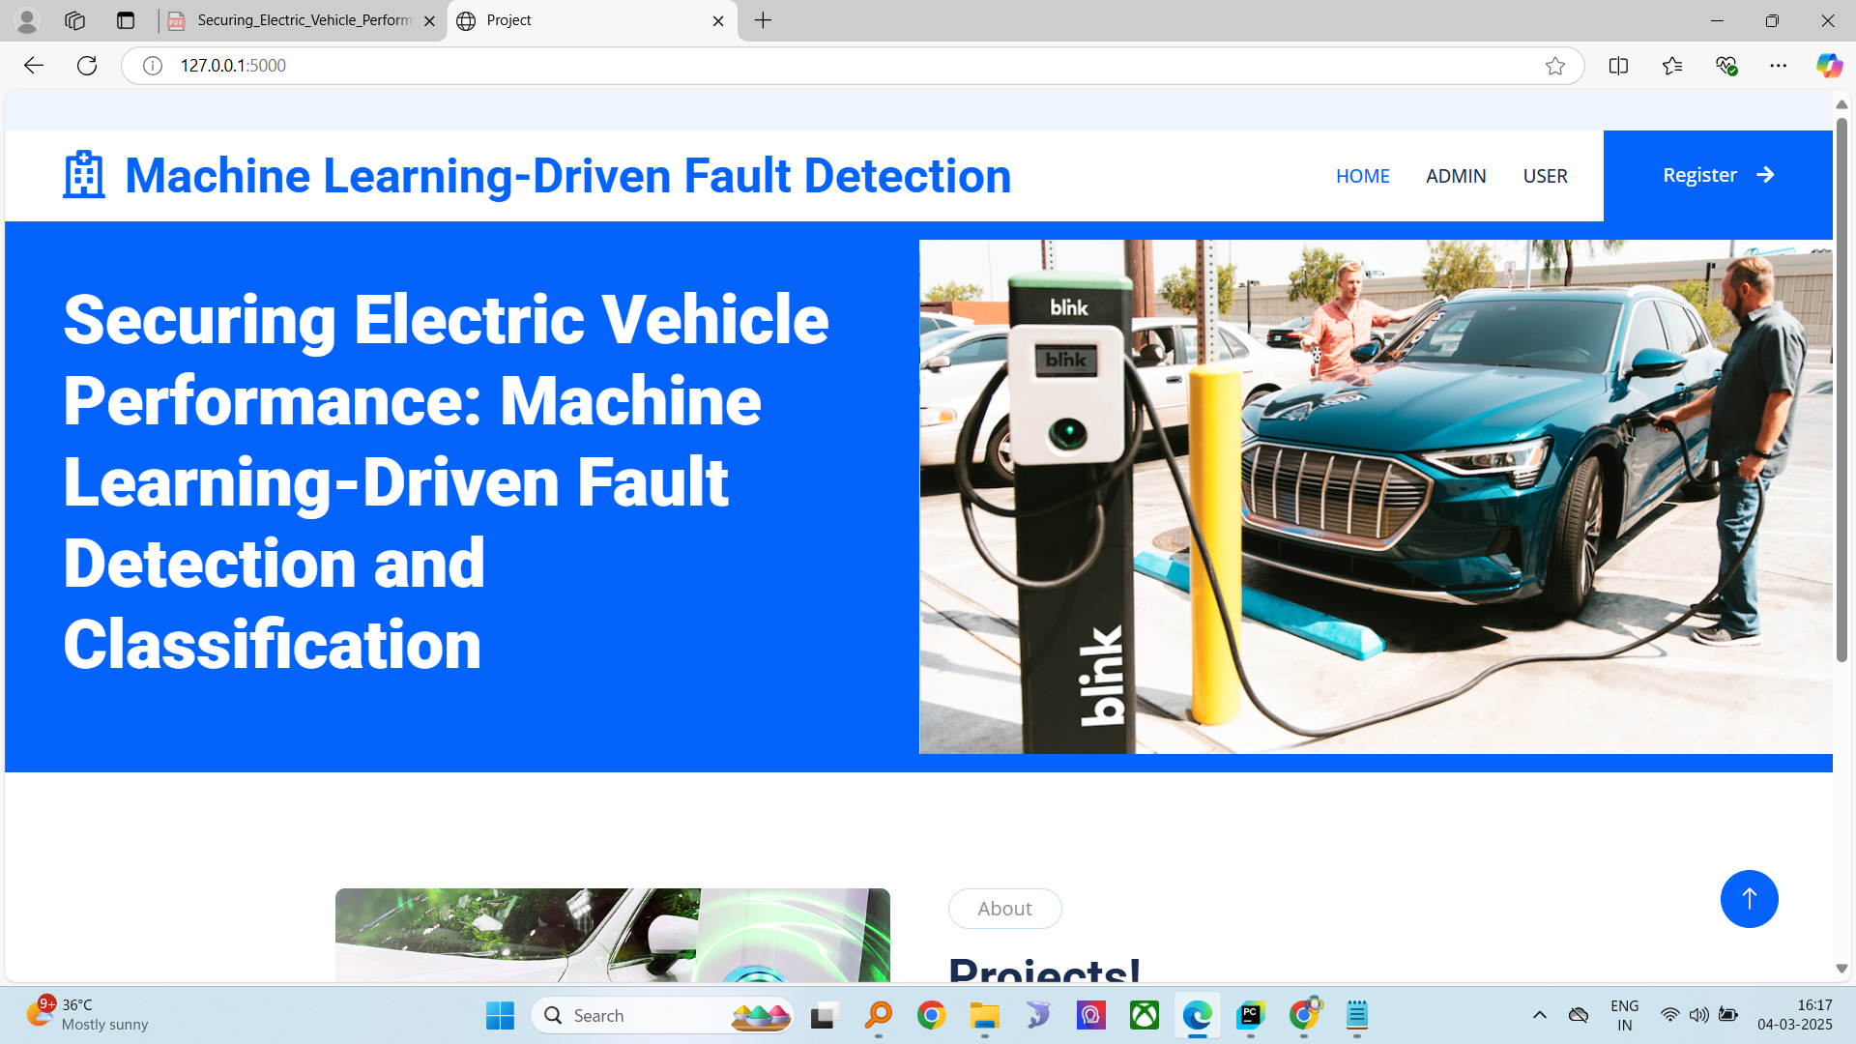

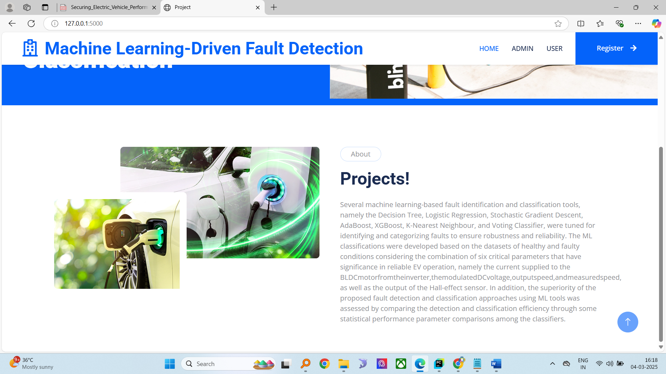

Admin login

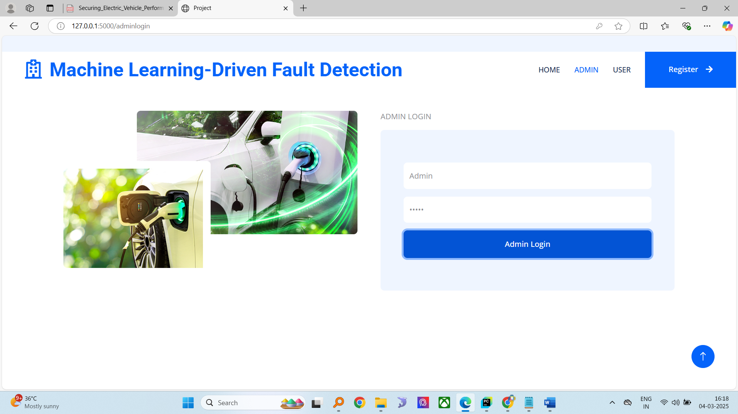

Admin home

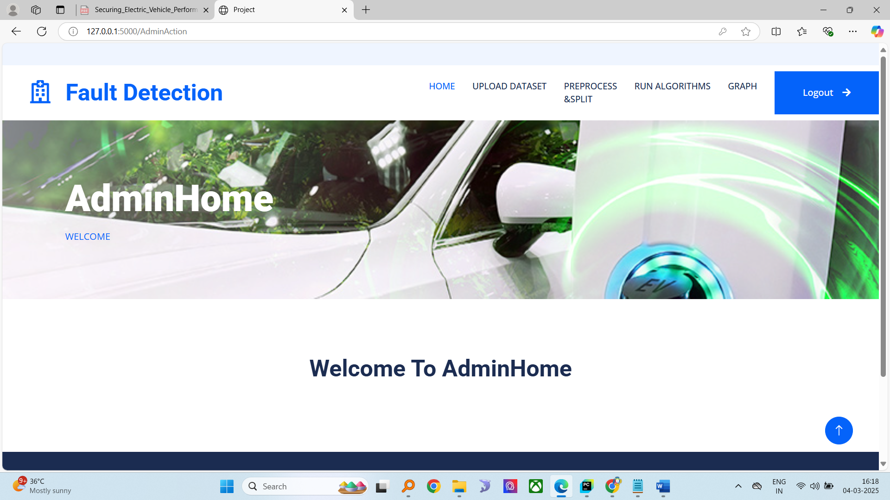

Upload dataset

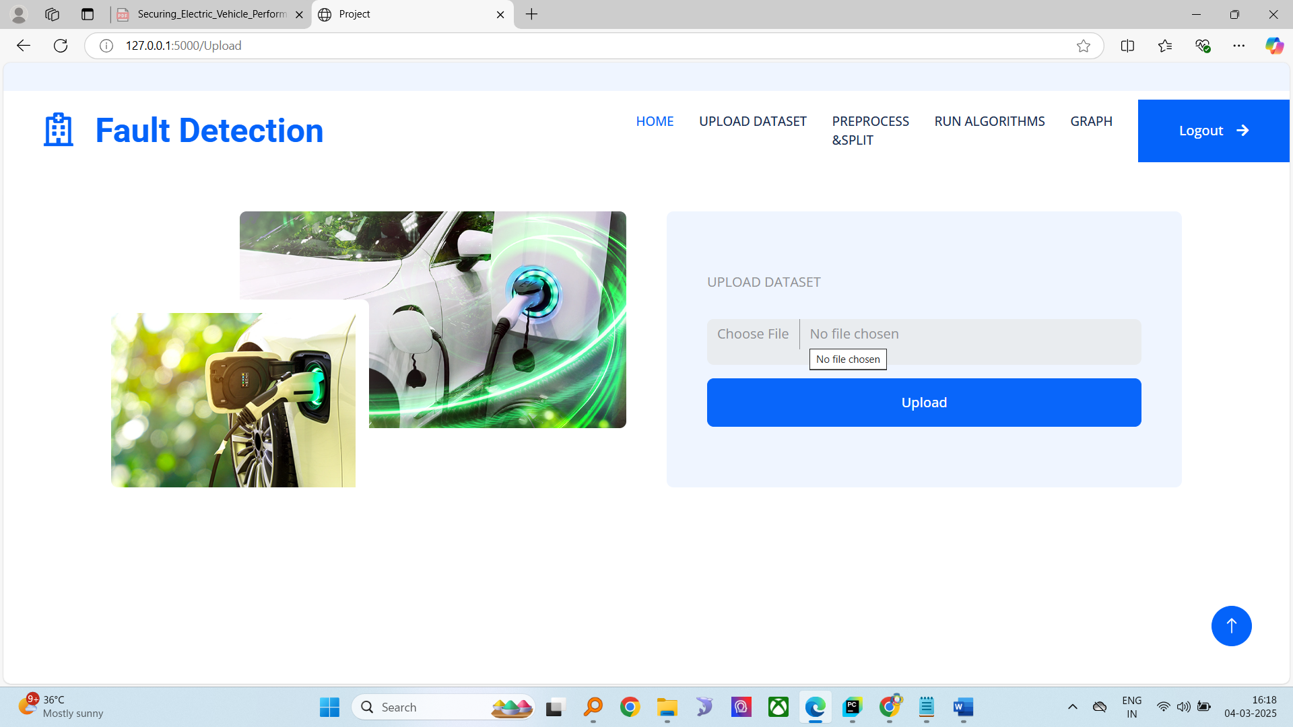

Dataset view

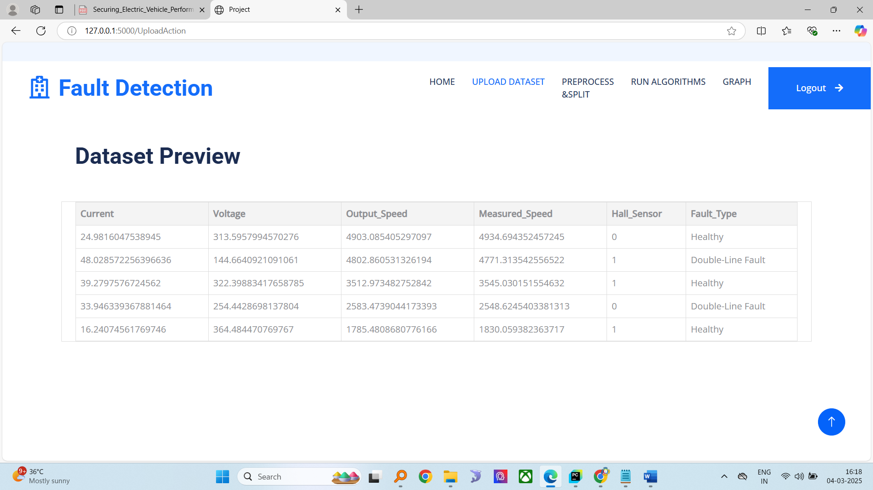

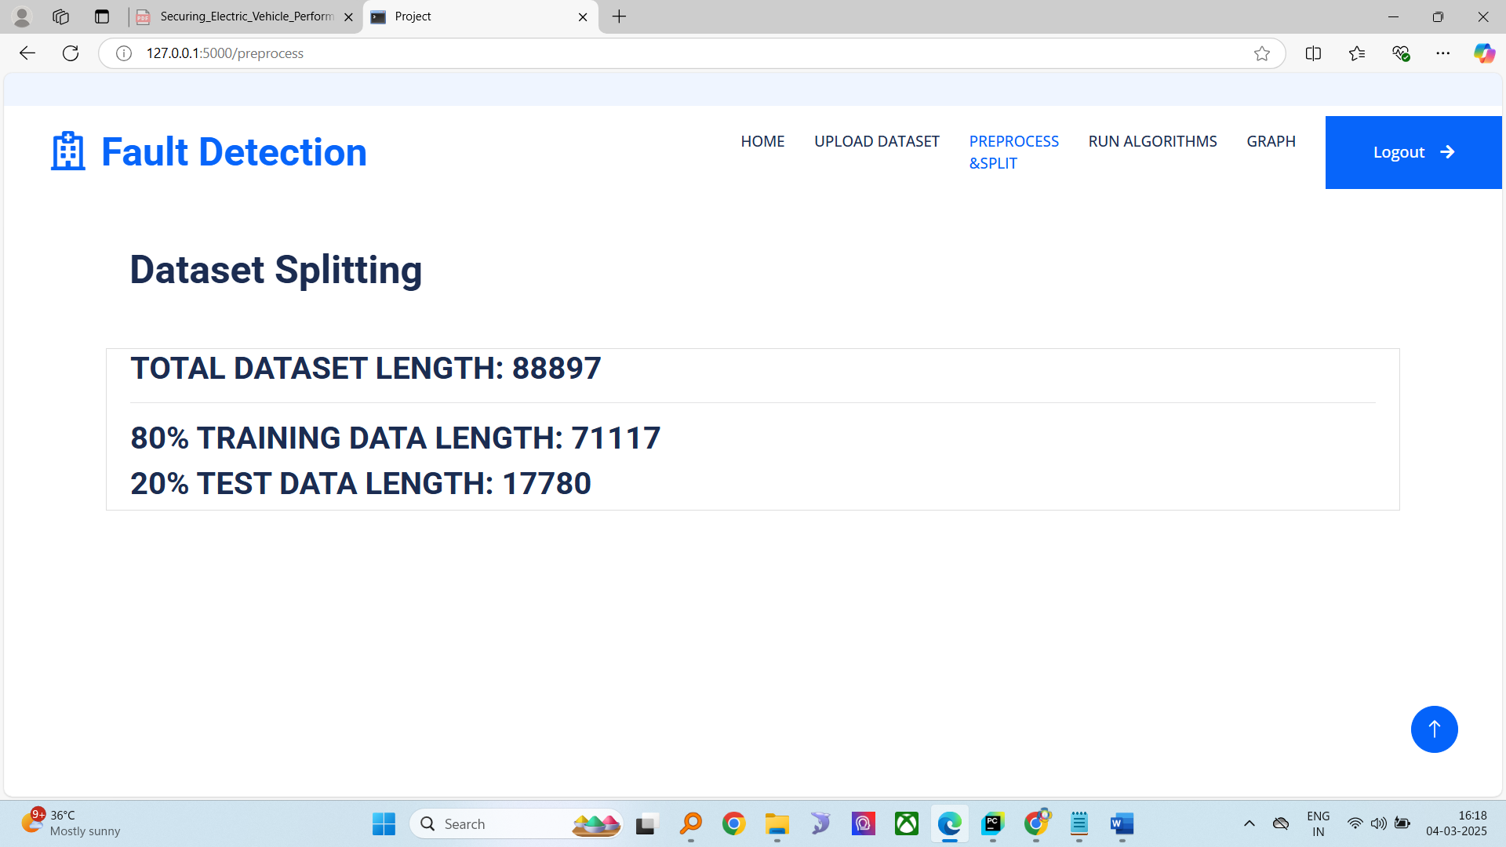

Model accuracy graphs

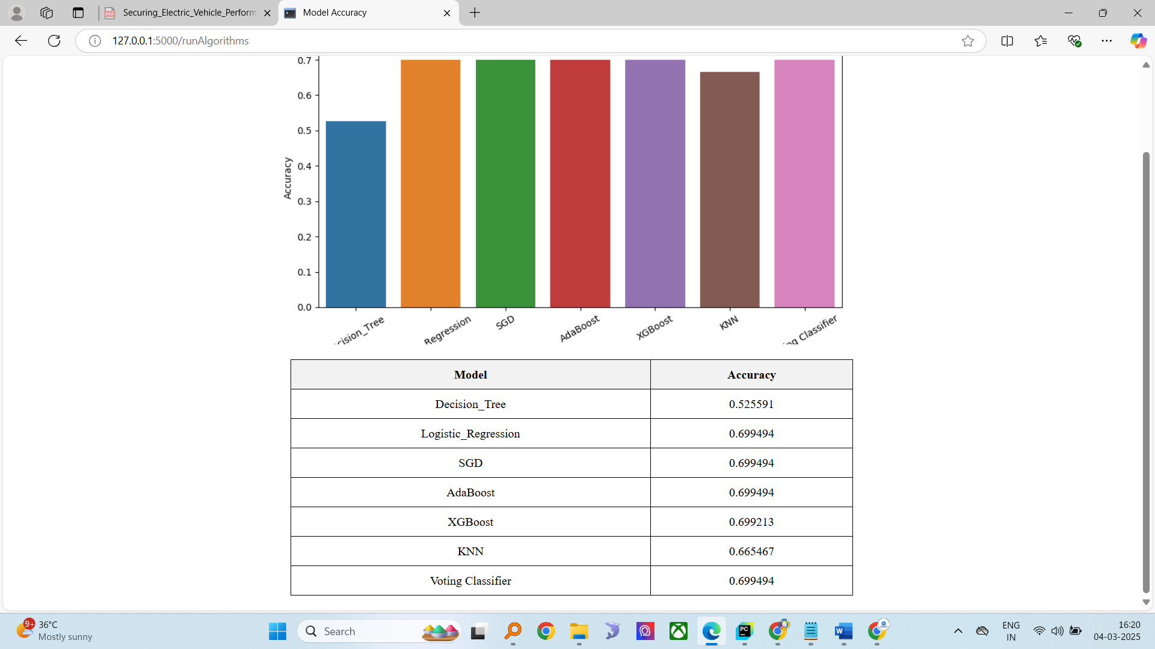

User registration

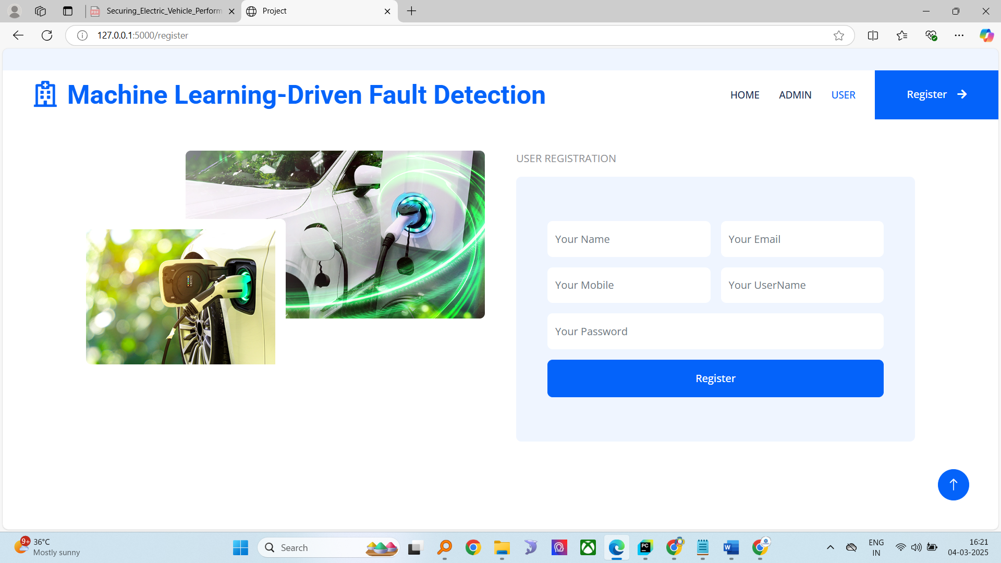

User login

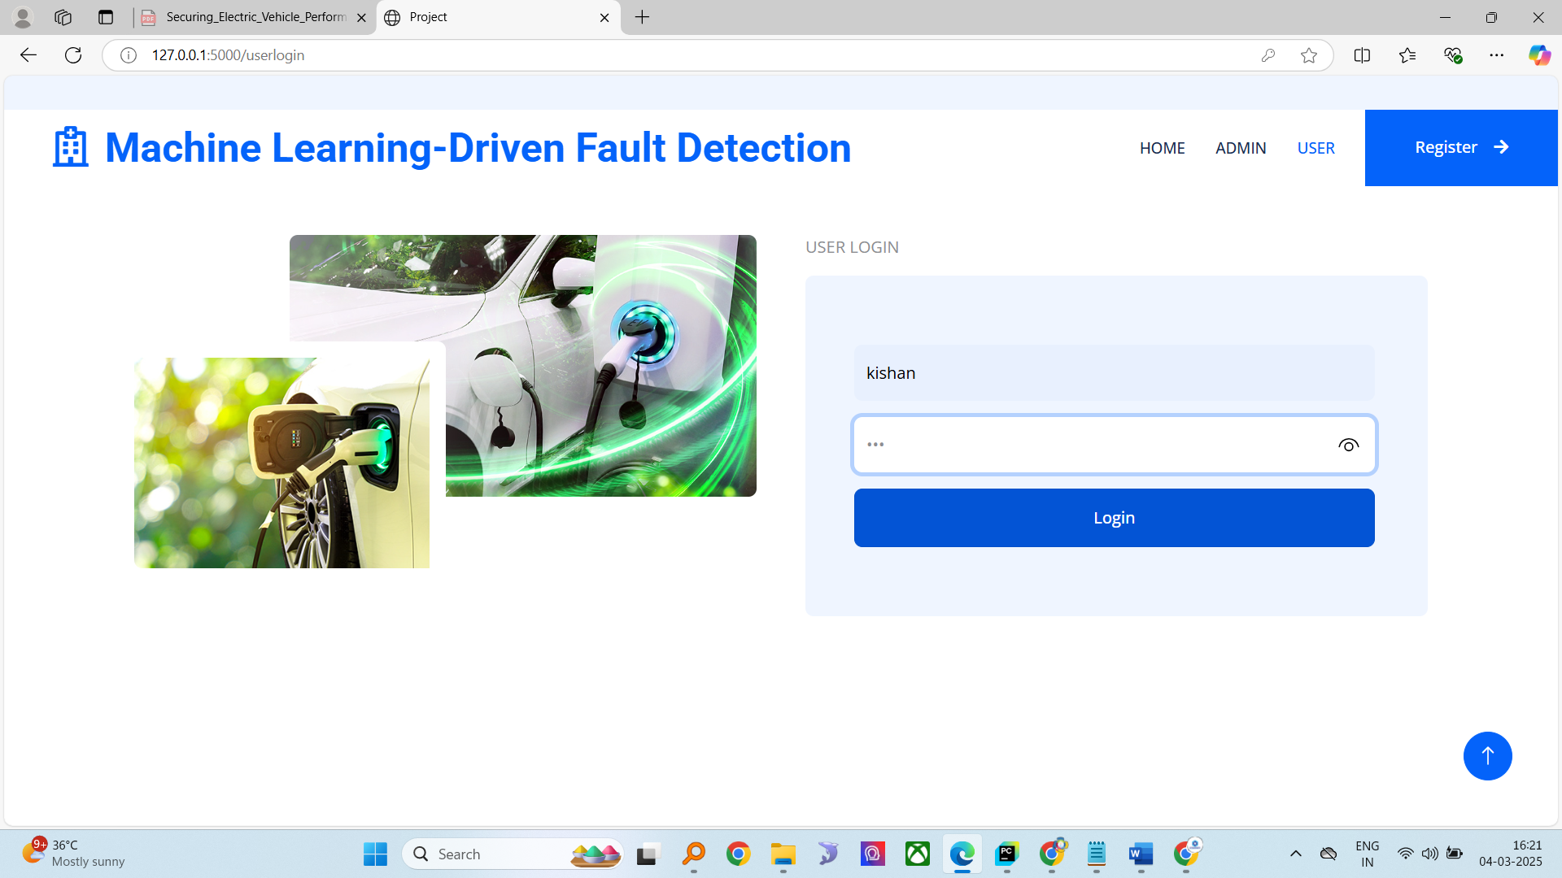

User home

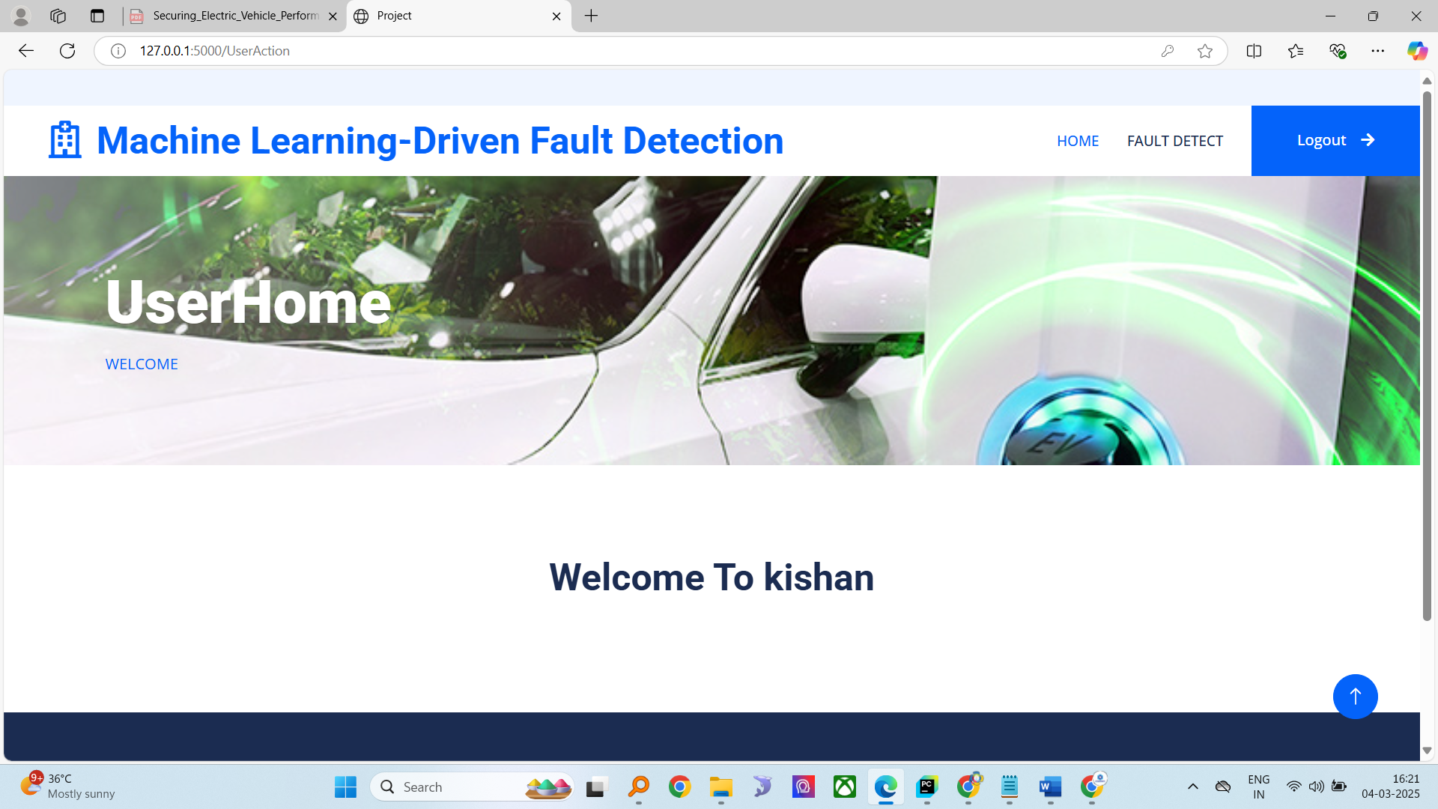

Detect fault

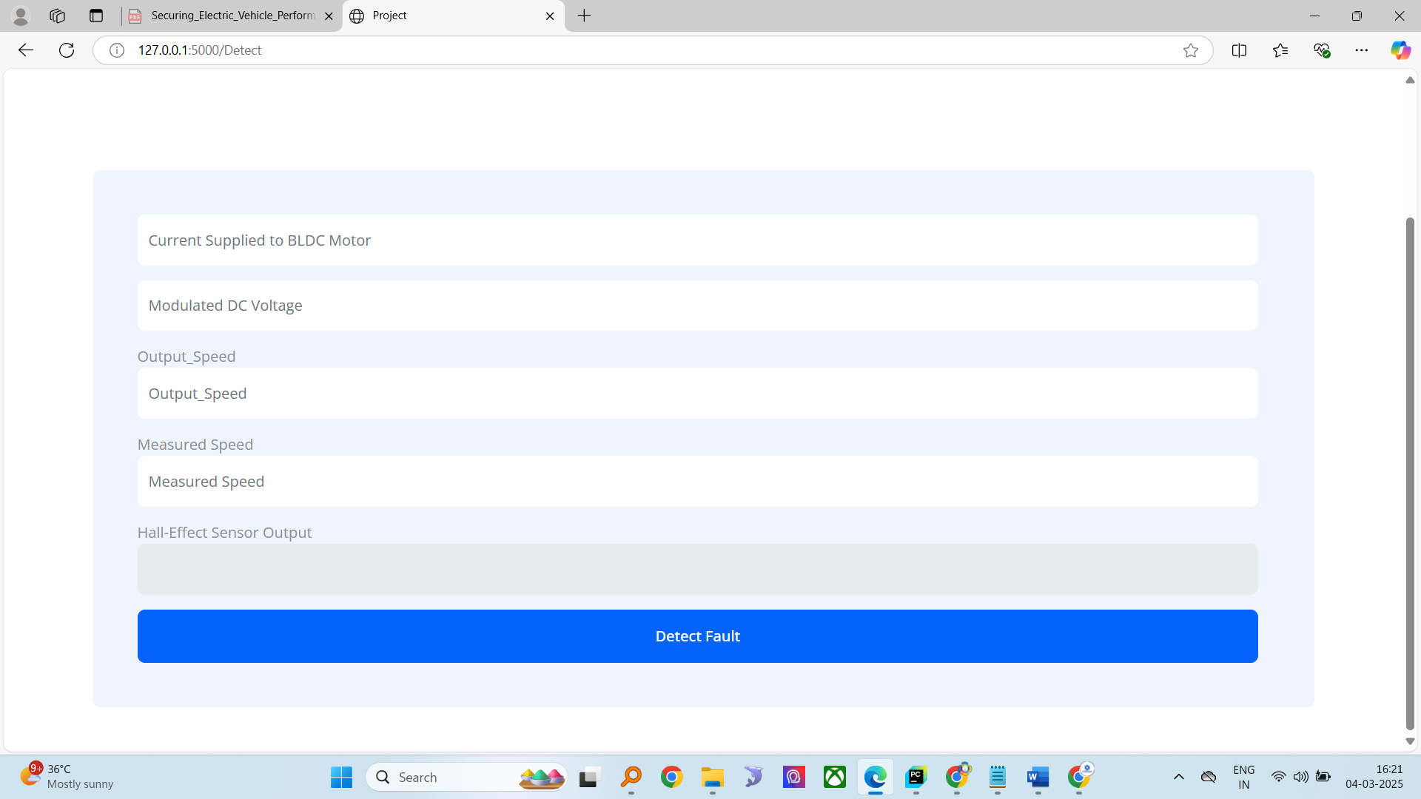

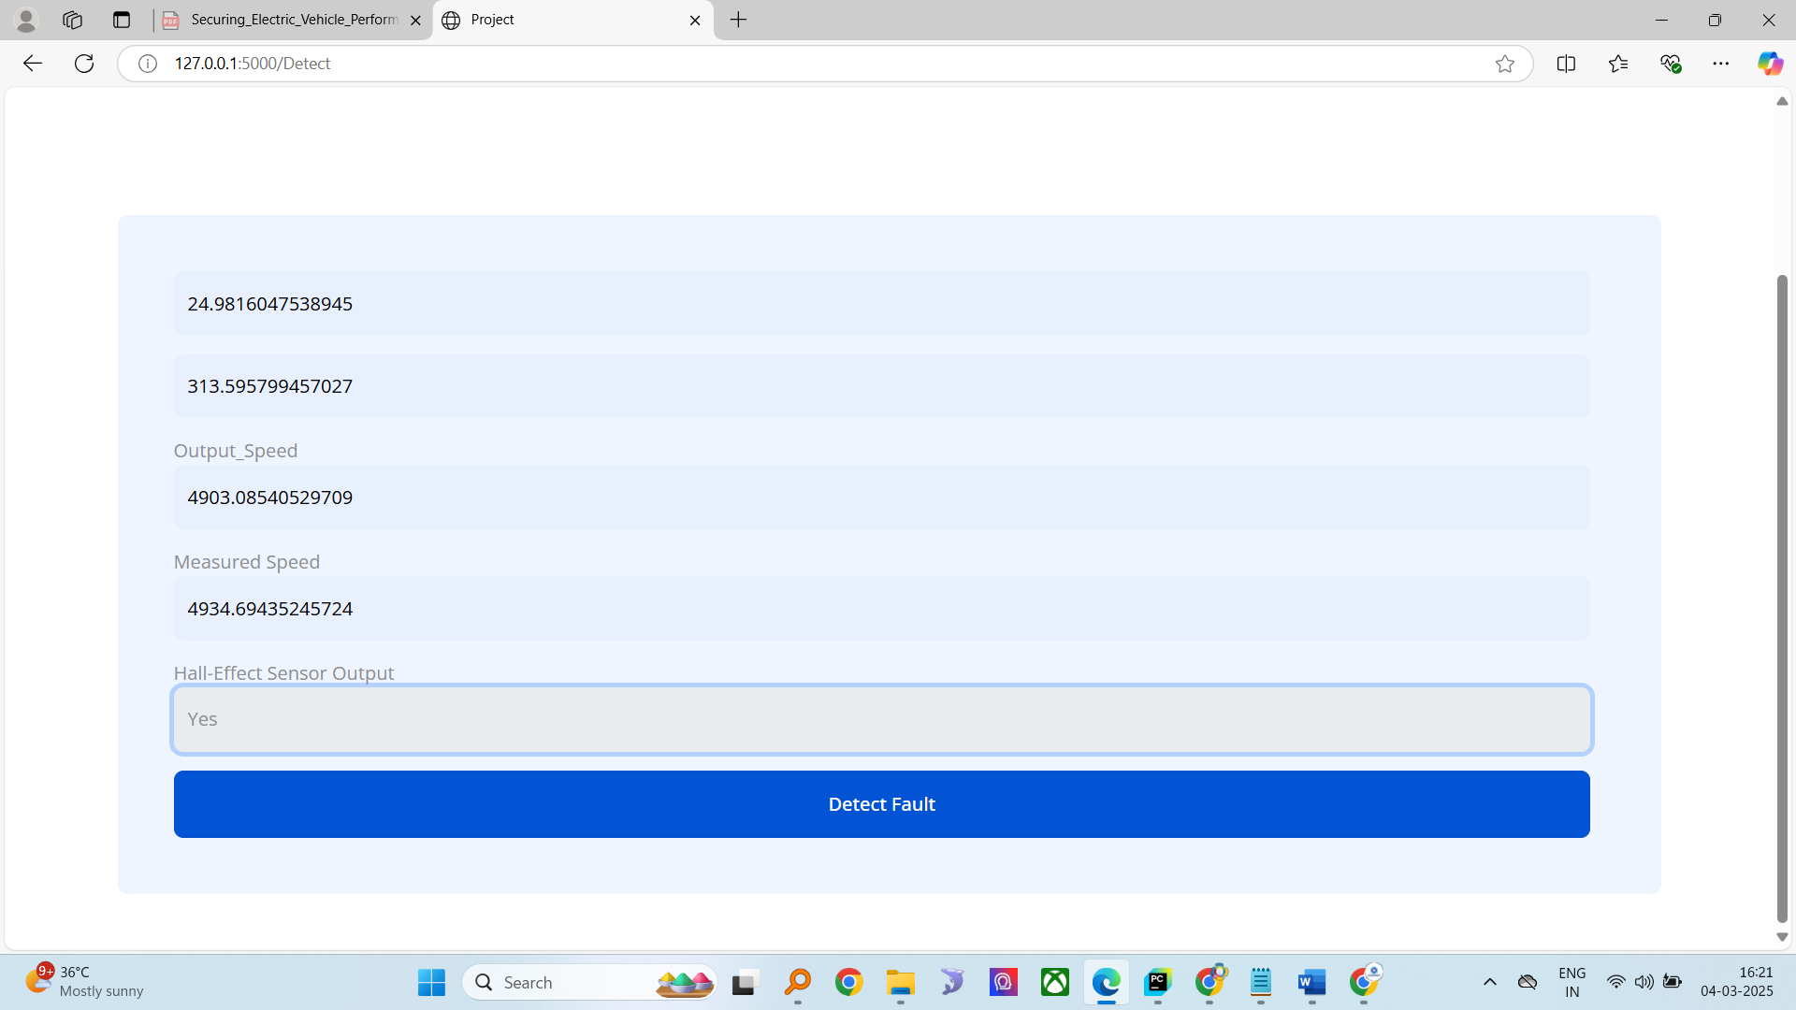

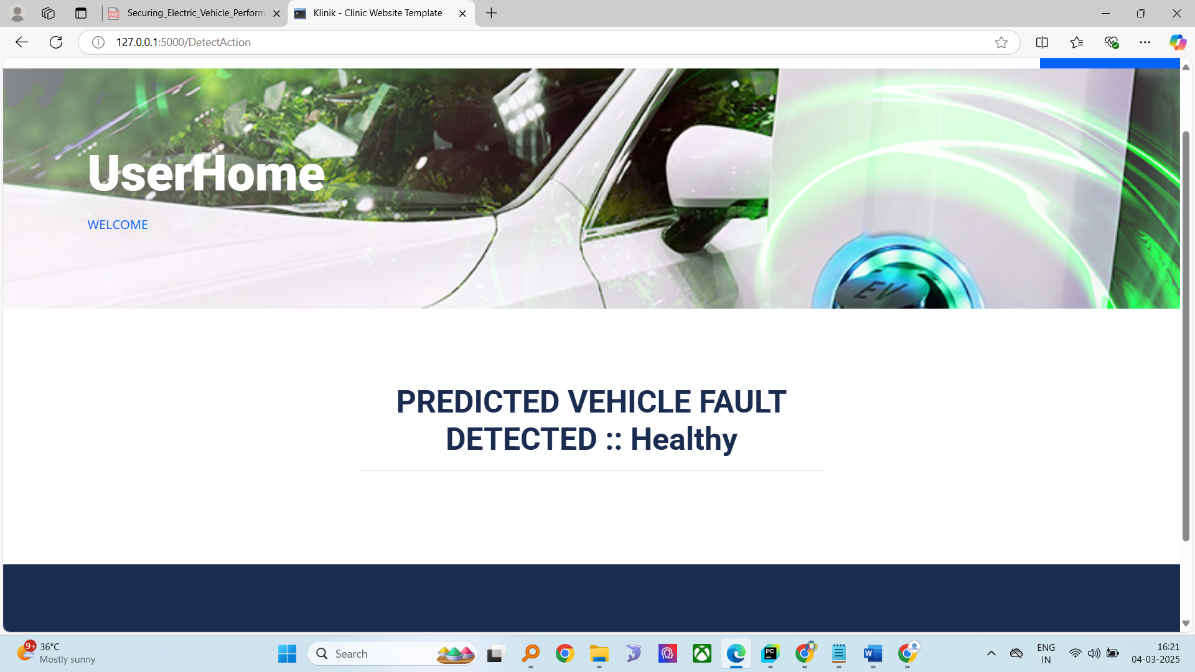

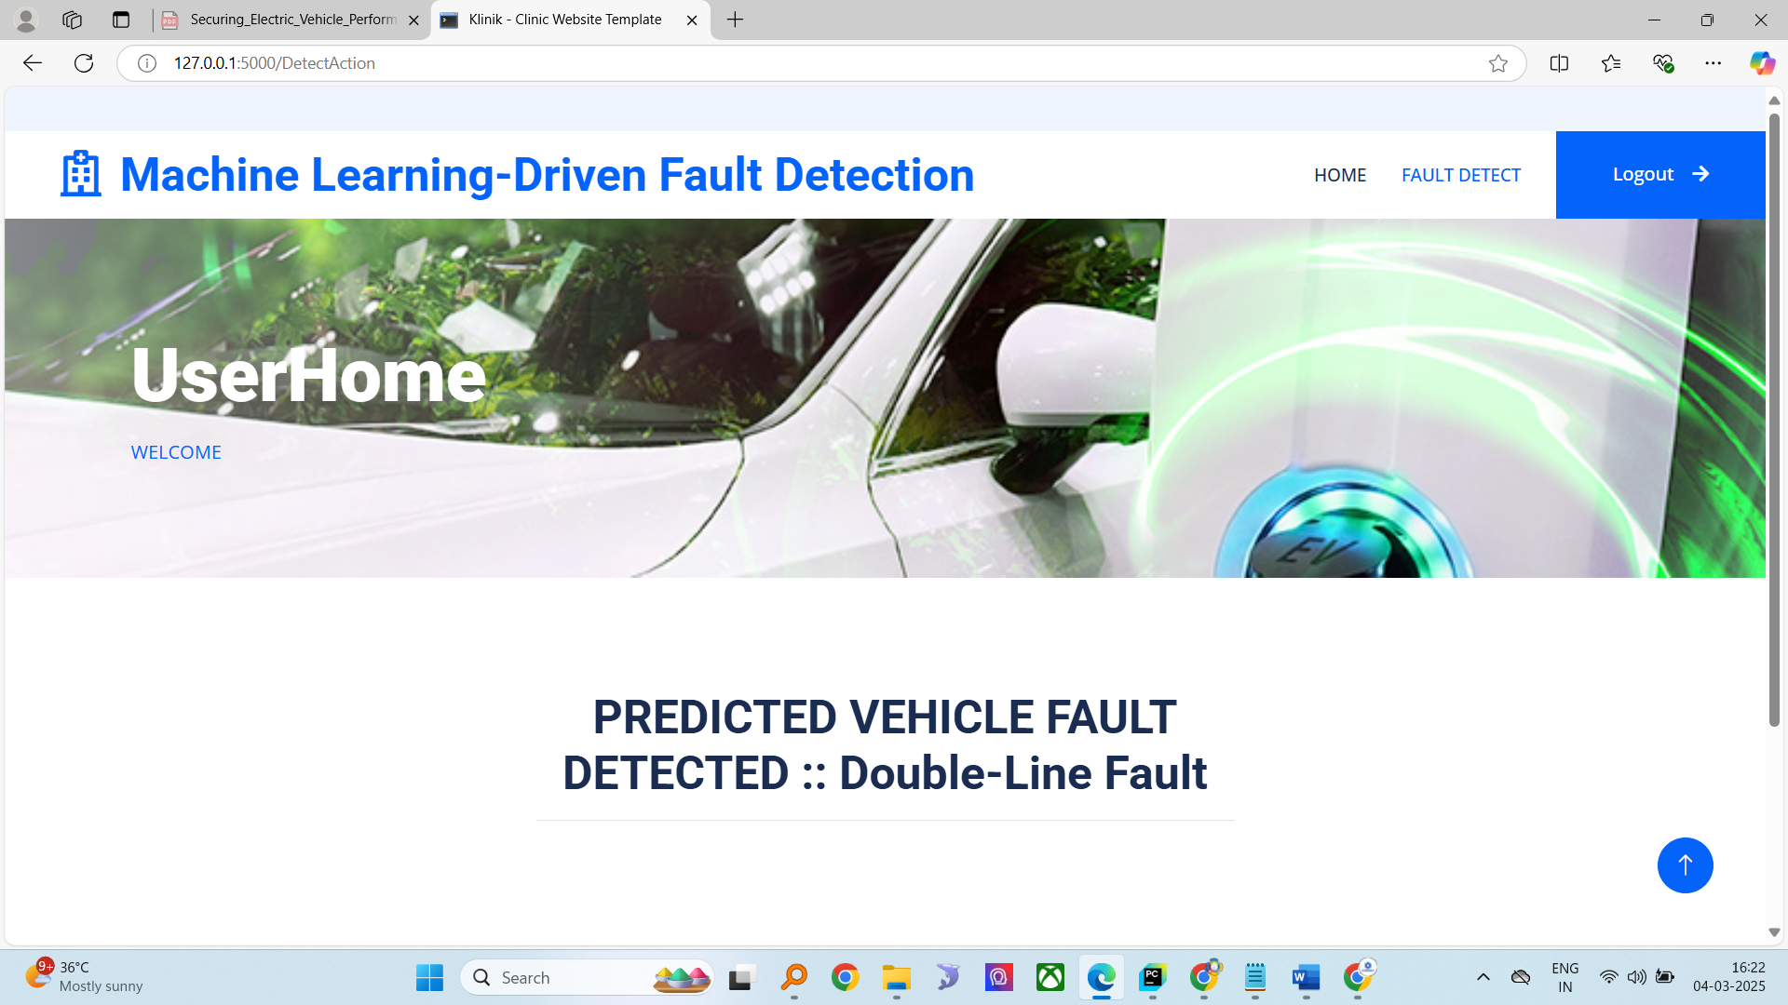

**SAMPLE CODE**

UPLOAD_FOLDER = './uploads'

app.config['UPLOAD_FOLDER'] = UPLOAD_FOLDER

os.makedirs(UPLOAD_FOLDER, exist_ok=True)

global dataset,filepath

@app.route('/UploadAction', methods=['POST'])

def UploadAction():

    global dataset,filepath

    if 'dataset' not in request.files:

        return "No file part"

    file = request.files['dataset']

    filepath = os.path.join(app.config['UPLOAD_FOLDER'], file.filename)

    file.save(filepath)

    dataset = pd.read_csv(filepath)

    columns = dataset.columns.tolist()

    rows = dataset.head().values.tolist()

    return render_template('AdminApp/ViewDataset.html', columns=columns, rows=rows)

global dataset, X_train, X_test, y_train, y_test

@app.route('/preprocess')

def preprocess():

    global dataset, X_train, X_test, y_train, y_test

    dataset = pd.read_csv("Dataset/ev_fault_dataset.csv")

    dataset.dropna(inplace=True)

    dataset['Fault_Type']=dataset['Fault_Type'].map({'Healthy':0, 'Double-Line Fault':1, 'Three-Phase Fault':2})

    # Split data

    X = dataset.drop(columns=['Fault_Type'])

    y = dataset['Fault_Type']

    X_train, X_test, y_train, y_test = train_test_split(X, y, test_size=0.2, random_state=42)

    return render_template('AdminApp/SplitStatus.html', total=len(X), train=len(X_train),test=len(X_test))

global results

@app.route('/runAlgorithms')

def runAlgorithms():

    global X_train,X_test,results

    # Standardization

    scaler = StandardScaler()

    X_train = scaler.fit_transform(X_train)

    X_test = scaler.transform(X_test)

    # Save Scaler

    joblib.dump(scaler, "Model/scaler.pkl")

    # Models

    models = {

        'Decision_Tree': DecisionTreeClassifier(),

        'Logistic_Regression': LogisticRegression(max_iter=1000),

        'SGD': SGDClassifier(),

        'AdaBoost': AdaBoostClassifier(),

        'XGBoost': GradientBoostingClassifier(),

        'KNN': KNeighborsClassifier()

    }

    # Train, Save, and Evaluate Models

    results = {}

    for name, model in models.items():

        model.fit(X_train, y_train)

        joblib.dump(model, f"Model/{name}.pkl")

        y_pred = model.predict(X_test)

        acc = accuracy_score(y_test, y_pred)

        results[name] = acc

        print(f"{name} Accuracy: {acc:.4f}")

        print(classification_report(y_test, y_pred))

    # Voting Classifier

    voting_clf = VotingClassifier(estimators=[

        ('DT', DecisionTreeClassifier()),

        ('LR', LogisticRegression(max_iter=1000)),

        ('SGD', SGDClassifier()),

        ('AB', AdaBoostClassifier()),

        ('XGB', GradientBoostingClassifier()),

        ('KNN', KNeighborsClassifier())

    ], voting='hard')

    voting_clf.fit(X_train, y_train)

    joblib.dump(voting_clf, "Model/Voting_Classifier.pkl")

    y_pred_voting = voting_clf.predict(X_test)

    voting_acc = accuracy_score(y_test, y_pred_voting)

    results['Voting Classifier'] = voting_acc

    print(f"Voting Classifier Accuracy: {voting_acc:.4f}")

    print(classification_report(y_test, y_pred_voting))

    # Plot Accuracy Comparison

    plt.figure(figsize=(10, 5))

    sns.barplot(x=list(results.keys()), y=list(results.values()))

    plt.xlabel('Model')

    plt.ylabel('Accuracy')

    plt.title('Comparison of Machine Learning Models')

    plt.xticks(rotation=30)

    plt.savefig('static/model_accuracy.png')

    plt.close()

    # Save results to HTML table

    results_df = pd.DataFrame(list(results.items()), columns=['Model', 'Accuracy'])

    html_table = results_df.to_html(index=False)

    html_page = f"""

    <!DOCTYPE html>

    <html>

    <head>

        <title>Model Accuracy</title>

        <style>

            table {{ width: 50%; border-collapse: collapse; margin: 20px auto; }}

            th, td {{ border: 1px solid black; padding: 10px; text-align: center; }}

            th {{ background-color: #f2f2f2; }}

        </style>

    </head>

    <body>

        <h2 style="text-align:center;">Machine Learning Model Accuracy</h2>

        <img src="/static/model_accuracy.png" alt="Model Accuracy Graph" style="display: block; margin: 20px auto; width: 60%;">

        {html_table}

    </body>

    </html>

    """

    with open("templates/results.html", "w") as f:

        f.write(html_page)

    return render_template('results.html', msg="All Model Generated Successfully..!!")

**CONCLUSION**

The integration of machine learning techniques for fault detection and classification in EVs represents a significant advancement over traditional fault diagnosis methods. By leveraging multiple ML classifiers, the proposed system improves detection accuracy, minimizes false positives, and enhances overall reliability. The comparative analysis of classifiers provides insights into the most effective fault detection approaches, contributing to the development of robust EV fault management systems. Future research can explore the integration of deep learning models for further enhancing fault classification capabilities and ensuring real-time adaptability in evolving EV architectures.

**REFERENCES**

1. IEEE Transactions on Transportation Electrification – Machine Learning Approaches for EV Fault Diagnosis.
2. Journal of Electrical Engineering – Fault Detection in Brushless DC Motors Using AI Techniques.
3. International Conference on Intelligent Transportation Systems – Application of ML in EV Fault Analysis.
4. Elsevier – Comparative Study of ML Classifiers for Fault Identification in EVs.
5. Springer – Enhancing EV Reliability through Machine Learning-Based Fault Diagnosis.
6. IET Power Electronics – Advanced ML Techniques for Fault Classification in BLDC Motors.
7. International Journal of Automotive Technology – Adaptive ML Models for EV Fault Detection.
8. Sensors Journal – Hall-Effect Sensor-Based Fault Detection in Electric Vehicles.
9. IEEE Access – Stochastic Gradient Descent and XGBoost for EV Fault Diagnosis.
10. Journal of Renewable and Sustainable Energy – AI-Based Fault Management in Smart EV Systems.